Munim Build Plan

What judges score, and the one-line strategy
Win on working voice + a credit offer that follows a cash-flow forecast; every other Track 1 team is already pitching "multi-agent copilot with human approval". The Hyderabad listing names the criteria as innovation, technical implementation, originality, problem solving and presentation (hiretoday); the Delhi brief asks for solutions that help merchants grow, manage operations and serve customers (devSemble).
Criterion | What earns it for Munim | What loses it
Technical implementation | Live Telugu/Hindi voice round-trip, agent answers grounded in SQL you can show | A Streamlit page with canned text
Innovation / originality | Soundbox as the channel; forecast → pre-approved credit; voice approval | Dashboard + chatbot + "AI" in the name
Problem solving | One merchant story, told end to end, with the number the agent found | Feature tour with no story
Presentation | Deck (done) + 2-minute live demo + honest real-vs-simulated slide | Reading slides; demo that needs Wi-Fi it doesn't have
Assumptions this plan makes (correct me and I'll adjust): a one-day offline finale of roughly 8 build hours, a team of 1–2, a few days of prep before it, and your own laptop with internet. Build the core at home; the event day is for polish, integration and rehearsal, not first lines of code.

Scope: live, simulated, cut
Build five things that work live, simulate the Paytm-side plumbing openly, and cut everything else. Judges reward a narrow demo that never breaks over a wide one that stutters.
Feature | Status in the demo | Why
Daily voice briefing (Hindi or Telugu) from real computed KPIs | Live | Your headline differentiator; must be heard in the room
Ask anything ("settlement kyun kam aaya?") answered from SQL over the data | Live | Proves grounding; judges will test it
Cash-flow forecast with a predicted gap and a pre-approved credit card | Live (simple forecast) | Ties Munim to Paytm's lending business
Growth agent proposes a promo to repeat customers; merchant approves by tap or voice | Live proposal and approval | Human-in-the-loop is table stakes, so it must at least work
Promo actually sent, credit actually disbursed | Simulated, labelled | No Paytm production APIs; say so on the tech slide
Soundbox | Simulated as an on-screen device that plays the TTS audio | Nobody has Soundbox firmware access; the simulation still lands the idea
Multi-merchant, login, real Paytm data, inventory, GST filing, WhatsApp delivery | Cut | Each one costs hours and wins nothing on the rubric
Definition of done for the event: a judge can say one Hindi sentence into your laptop mic and hear a correct answer back within about 5 seconds, with the SQL that produced it visible on screen.

Architecture and stack
Keep the stack exactly what the deck promises (LangGraph, GPT-4o / LLaMA 3.3, Django, PostgreSQL, AWS) so slide 4 and the repo match; add one named Indic speech provider, because "STT/TTS" without a vendor sounds unbuilt.
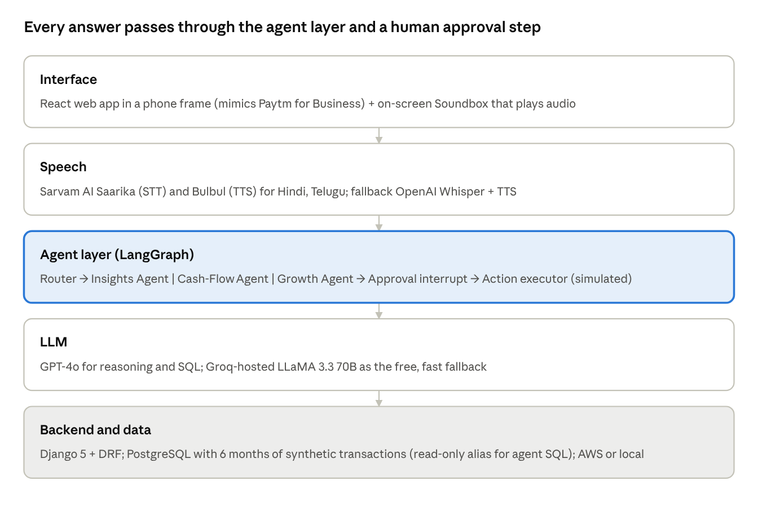
Munim architecture · 5 layers
Requests flow top to bottom; audio and approvals flow back up. The accent band is where the hackathon's real work lives.
Layer | Pick | Fallback if it fails on the day
Frontend | React + Vite + Tailwind, single page, 390×844 phone frame | Keep the same app; the frame is just CSS
Speech | Sarvam AI Saarika STT + Bulbul TTS (Indic-first, Hindi and Telugu) | OpenAI Whisper + tts-1; last resort: pre-recorded MP3s for the demo lines
Agents | LangGraph StateGraph with an interrupt() node for approval | Plain Python functions calling the LLM in sequence; judges never see the graph
LLM | GPT-4o (gpt-4o) for SQL generation and briefing text | Groq llama-3.3-70b-versatile, free tier, very fast
Backend | Django 5 + Django REST Framework, one process via runserver; plain REST, audio in as multipart POST, MP3 back; django-cors-headers for the Vite dev server; a second DATABASES alias on a read-only Postgres role for run_sql | Same
Database | PostgreSQL 16 in Docker, or a free Neon instance; SQLAlchemy | SQLite file with the same schema (keeps Postgres in the pitch, swaps the connection string)
Forecast | Weekly seasonality + 7-day moving average in pandas, or statsmodels Holt-Winters | Moving average only
Hosting | Localhost on the demo laptop; AWS EC2 or Render only if time remains | Localhost is the plan, not the fallback
Two rules that save the demo: every LLM call has a 10-second timeout and a cached response for the three scripted demo questions, and the frontend never shows a spinner for more than 6 seconds without a partial result (play the first TTS sentence while the rest generates).

Synthetic data: one merchant, five planted stories
Generate 6 months of transactions for one merchant persona and plant five patterns in it; the demo is the agent finding those patterns. One rich merchant beats three thin ones.
Persona: Lakshmi Kirana, a grocery store in Kukatpally, Hyderabad. Owner speaks Telugu and Hindi. About 90 transactions a day, average ticket ₹185, open 7 am to 10 pm, Paytm QR plus Soundbox.
Tables (PostgreSQL):
Table | Columns | Rows
merchants | merchant_id, name, category, city, language, onboarded_on | 1
transactions | txn_id, merchant_id, ts, amount, customer_hash, mode (UPI/card/wallet), status (success/refund/failed), settlement_id | ~16,000
settlements | settlement_id, date, gross, mdr_fee, refunds, chargebacks, net, credited_on | ~180
customers | customer_hash, first_seen, last_seen, visit_count | ~1,400
obligations | id, label (supplier payment, rent, EMI), amount, due_on | ~12
offers | offer_id, type (credit/promo), amount, status (proposed/approved/rejected/sent), created_at | grows during the demo
The five planted stories (the generator must create these deliberately, with a seed so they are identical on every run):
- Evening slump. Sales between 6 pm and 9 pm are 35% below the 11 am to 1 pm peak on weekdays only. Briefing line: "evenings are slow."
- Yesterday's dip. The day before the demo date earns about 12% below the trailing 4-week average for that weekday (match the deck's ₹8,200 example).
- Short settlement. One settlement 3 days ago is ₹1,420 short of gross: ₹890 in two refunds, ₹530 MDR on card transactions. This is the answer to "why is my settlement short?"
- Repeat customers. About 18% of customer hashes account for roughly 55% of revenue; 40 of them have not visited in 14+ days. This is the Growth Agent's promo target.
- Cash crunch in 9 days. A ₹45,000 supplier payment is due on day +9; the forecast of net inflows minus obligations dips below zero on day +7. The Cash-Flow Agent surfaces a pre-approved ₹30,000 working-capital offer.
Generator: one Python script, seed.py, using numpy with seed=42 and Faker for names. Base daily volume with weekly seasonality (Sunday +20%, Tuesday −10%), a festival spike on one date, hourly curve with two peaks, then inject the five stories as explicit overrides. Write to Postgres with pandas.to_sql. Target: regenerates in under 10 seconds so you can reset between judge rounds.
Pin the "today" of the demo as a constant (DEMO_TODAY) rather than date.today(), so the stories do not drift if the finale is a week later than you built.

Agent design
Three narrow agents behind one router, with a LangGraph interrupt() as the only path to an action. Narrow agents with fixed tools are reliable in a demo; one "do everything" agent is not.
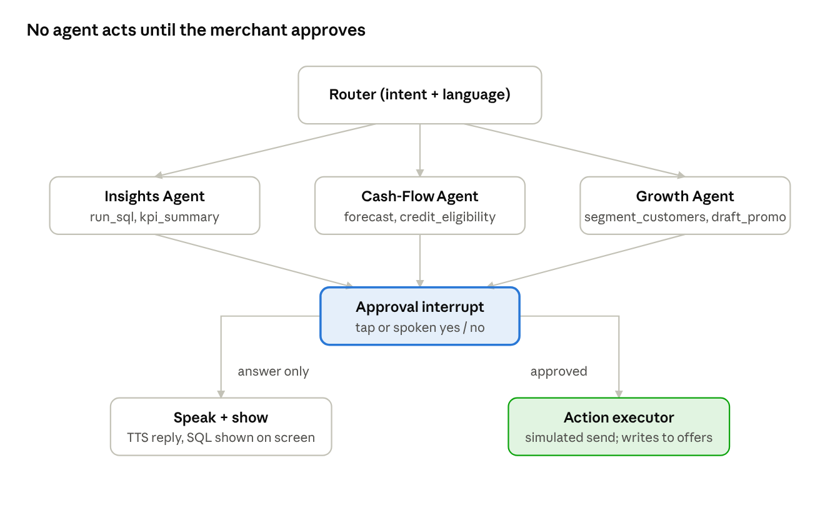
Munim agent graph · 3 agents, 1 approval gate
Questions end at "Speak + show"; proposals pause at the approval gate and only an approved one reaches the executor.
Agent | Trigger | Tools | Output
Router | Every transcript | detect_language, intent classifier (LLM, 5 labels: briefing, question, forecast, growth, approval) | Which agent runs; the reply language
Insights | "briefing" or "question" | run_sql(query) on a read-only Postgres role; kpi_summary(day) returning yesterday vs 4-week average, peak and slow hours, repeat share | 2–4 sentence answer with the numbers, plus the SQL used
Cash-Flow | "forecast", or nightly in the briefing | forecast(days=14) (pandas), obligations(), credit_eligibility() (rule: 90-day average daily net × 15, capped) | Day of the predicted gap, its size, an offer object
Growth | "growth", or when Insights finds a lapsed-repeat segment | segment_customers(lapsed_days=14), draft_promo(segment, language) | A promo proposal: segment size, offer text, estimated reach (count, not revenue)
Approval gate | Any proposal | LangGraph interrupt(); resumes on {approved: true/false} from a tap or an STT'd "haan / avunu / yes" | Resumes graph or ends
Executor | Approved proposal | send_promo() and disburse_credit() as stubs that write to offers with status sent | A confirmation line the TTS speaks
Grounding rules (put these in the system prompt and say them to the judges):
- Every number spoken must come from a tool result in the same turn. The LLM never estimates a figure.
- SQL is generated against a fixed schema description and executed on a read-only connection; a failing query is retried once with the error, then the agent says it could not find it.
- The reply is drafted in English for logging, then rendered in the merchant's language by the LLM in one more call; both are stored so you can show the English to judges.
- Amounts are spoken in Indian style ("aath hazaar do sau rupaye"); format numbers before TTS.
Pre-compute the briefing. The daily voice briefing is generated once at startup for DEMO_TODAY and cached with its MP3. Pressing the Soundbox plays instantly; the live LLM path is reserved for the judge's questions, where latency is forgiven.

Voice pipeline and the Soundbox simulation
Target a 5-second round trip from the end of the merchant's sentence to the first spoken word, and make the Soundbox briefing instant by pre-rendering it.
Round trip: browser MediaRecorder records 16 kHz mono WebM on press-and-hold → POST /ask with the blob → Sarvam Saarika STT with language_code auto-detect (Hindi hi-IN, Telugu te-IN) → agent graph → reply text in the merchant's language → Sarvam Bulbul TTS → MP3 streamed back → <audio> autoplay. Show the transcript as soon as STT returns so the screen moves while the agent thinks.
Step | Pick | Budget | Fallback
STT | Sarvam Saarika (Indic, handles Hinglish and code-mixing) | ~1 s | OpenAI Whisper whisper-1 with language=hi
Reasoning | GPT-4o, one SQL call + one answer call | ~2–3 s | Groq LLaMA 3.3 70B (faster, slightly weaker SQL)
TTS | Sarvam Bulbul, one voice chosen in advance, speed 1.0 | ~1 s | OpenAI tts-1 (acceptable Hindi, poor Telugu); last resort: pre-recorded MP3s
Approval by voice: after a proposal, the app listens for 4 seconds; the transcript is matched against a small list (haan, ha, yes, avunu, sari, theek hai / nahi, no, kaadu, ledu) before any LLM call. This is fast, deterministic and demo-safe; say so to judges as a deliberate design choice.
Soundbox simulation: a second panel beside the phone frame, drawn as a device with a speaker grille and one blue button. Pressing it plays the cached morning briefing MP3 with a Soundbox-style chime first. In the pitch, say: "On real hardware this is a firmware update, not a new device; the Soundbox already has a speaker and a network connection." Do not claim you have built on the Soundbox.
Check before the event: Sarvam and OpenAI keys funded and tested on the venue Wi-Fi alternative (your phone hotspot); the demo laptop's mic input and speaker output selected and volume checked; browser autoplay allowed for localhost (Chrome needs one user click before audio plays, so the first click in the demo should be the Soundbox button).

Frontend: four screens, one page
One React page showing a 390×844 phone frame on the left and the Soundbox panel on the right; the phone has four screens reached by a bottom tab bar. Use Paytm blue #00BAF2 and navy #002E6E on white so it matches the deck, and label the frame "Paytm for Business (prototype)" so you are not accused of impersonating the real app.
Screen | What it shows | Live or static
Home | Yesterday's earnings vs average, a "Munim says" card with the briefing text and a play button, one alert card (settlement short, cash gap ahead) | Live from /briefing
Ask Munim | Press-and-hold mic button, transcript bubble, answer bubble, a collapsible "How I worked this out" panel showing the SQL and the rows | Live from /ask
Cash flow | 14-day line of forecast net balance with the gap shaded, obligations listed, the pre-approved credit card with Approve / Not now | Live from /forecast
Grow | Lapsed repeat-customer count, the drafted promo message in the merchant's language, Approve / Edit / Reject, and a "sent" state after approval | Live from /growth
Build order: Ask Munim first (it is the demo's core and the hardest), then Home, then Cash flow, then Grow. The Soundbox panel is 40 lines of CSS and one audio element; do it last.
Skip: login, settings, multi-language toggle (set the language in config), animations beyond a pulsing mic, and any screen the 5-minute script does not visit.

Pre-event plan, day by day
The working prototype exists before you walk in; the event day adds polish and rehearsal. Days are counted back from the finale (D). With two people, split as Backend (data, agents, voice API) and Frontend (React, audio, Soundbox); solo, follow the order top to bottom and drop the Grow screen if D-2 ends without it.
Day | Backend | Frontend | Done when
D-6 | Repo, Docker Postgres, seed.py with the five planted stories, schema doc for the LLM | Vite + Tailwind scaffold, phone frame, tab bar, mock JSON for all four screens | SELECT queries confirm each planted story exists
D-5 | Django project, models, migrations, DRF skeleton; run_sql tool with read-only role; Insights Agent answers the three scripted questions in English | Ask Munim screen wired to /ask with text input (no voice yet) | Typing "why is my settlement short" returns ₹1,420 with the breakdown
D-4 | Sarvam STT and TTS wrappers; /ask accepts audio; language detection; Hindi and Telugu rendering | Mic press-and-hold, transcript bubble, audio playback, SQL panel | A spoken Hindi question gets a spoken Hindi answer
D-3 | Cash-Flow Agent: forecast, obligations, eligibility rule, offer object; Growth Agent: segment + promo draft | Cash flow and Grow screens with Approve buttons calling /approve | Forecast shows the day +7 gap and the ₹30,000 offer; a promo can be approved and shows "sent"
D-2 | LangGraph graph with interrupt(); voice yes/no matching; cached briefing + MP3 at startup; timeouts and cached fallbacks for the scripted questions | Home screen, Soundbox panel, polish, Paytm colours, loading states | Full 5-minute script runs end to end on localhost
D-1 | Freeze code. README, architecture diagram, real-vs-simulated table, .env.example, one-command start (make demo) | Record a 2-minute backup demo video; export deck to PDF | Fresh clone + make demo works on the second laptop; video saved locally and on a phone
D-0 (night before) | Charge everything, phone hotspot tested, API keys funded, laptop sleep disabled, volume checked | Rehearse the script three times, timed | Under 5 minutes, twice in a row
If you have fewer days than this, merge D-6 with D-5 and D-3 with D-2; never cut D-1. A frozen, rehearsed prototype beats one more feature every time.

Event day, hour by hour
Plan for an 8-hour build window (the Bengaluru edition ran 10 am to 5 pm); adjust the clock to the schedule you are given, but keep the proportions: a third integration and fixes, a third polish, a third rehearsal and submission.
Time | Do | Not this
Hour 0 (arrive) | Hotspot on, make demo, run the full script once on venue Wi-Fi and once on hotspot; note which is faster | Start coding before the smoke test
Hours 1–2 | Fix anything the smoke test broke; add the one mentor-suggested tweak if it is under 30 minutes | New features
Hours 3–4 | Polish the visible path: Home card copy, number formatting, mic feedback, SQL panel readability; re-record briefing MP3 if the voice changed | Refactoring, tests, deploying to AWS
Hour 5 | Freeze. Commit, tag finale, push. Update README real-vs-simulated table to match exactly what runs | Any code change after this except a demo-blocking bug
Hour 6 | Rehearse three times with a timer; one person plays the judge and asks an unscripted Hindi question | Rehearsing only the happy path
Hour 7 | Submit (repo link, deck PDF, demo video, team details); check the submission form twice | Leaving submission to the last 10 minutes
Hour 8 (pitch) | Laptop on power, hotspot on, browser already on Home, audio volume tested on the room speaker if there is one | Opening the app after you start talking
Mentor check-ins: ask every mentor the same two questions ("What would make you not believe this?" and "What's the one thing you'd cut?") and act on only what two mentors agree on.

The 5-minute script
Two minutes of deck, two and a half of live demo, thirty seconds to close. The demo visits exactly the four planted stories in order; every line the agent speaks is one you have heard in rehearsal.
Time | Slide or screen | You say | What happens
0:00–0:20 | Slide 1 | "Every Paytm merchant used to have a munim, an accountant who knew the business. Lakshmi in Kukatpally doesn't. We built her one." | —
0:20–0:50 | Slide 2 | Three pain points in one breath each; land on "Paytm stays a QR on the counter." | —
0:50–1:20 | Slide 3 | "Munim talks, predicts and acts. Let me show you instead of telling you." | Switch to the app
1:20–1:50 | Soundbox panel | "It's 7 am. Lakshmi opens the shop and presses the Soundbox." Press it. | Cached Telugu or Hindi briefing plays: yesterday ₹8,200, 12% down, evenings slow. Subtitles on the Home card
1:50–2:30 | Ask Munim | "She heard the settlement was short. She just asks." Hold mic, speak in Hindi: "Mera settlement kam kyun aaya?" | Transcript appears, answer spoken: ₹1,420 short, ₹890 refunds, ₹530 card fees. Open the SQL panel for two seconds: "Every number comes from a query, not from the model's imagination."
2:30–3:10 | Cash flow | "Munim also looks ahead." | Forecast line dips below zero on day 7; supplier payment on day 9; pre-approved ₹30,000 card. "This is where Paytm's lending business meets the merchant's actual need, nine days early." Tap Approve.
3:10–3:50 | Grow | "And it finds growth. Forty regular customers haven't visited in two weeks." | Promo drafted in Telugu. Say "avunu" into the mic. Status flips to Sent. "Nothing happens without her yes."
3:50–4:20 | Slide 4 | "Under the hood: Sarvam for Indic speech, LangGraph agents with an approval gate, GPT-4o, Django and Postgres. The data is synthetic; the pipeline is real; the send is simulated." | —
4:20–4:45 | Slides 5–7 | One sentence each: Soundbox and lending are things only Paytm can do; merchants get an accountant, Paytm gets better loans and stickier merchants; free core, revenue from lending, Pro, campaigns. | —
4:45–5:00 | Slide 8 | "From payments to a partner for every merchant. Thank you." | —
If the live voice fails once, repeat the question. If it fails twice, say "Let me show you the recorded run" and play the 2-minute video without apologising further. Rehearse that switch too.

Risks and fallbacks
Every risk below has a fallback that is built before the event, not improvised during it.
Risk | Likelihood | Fallback already in place
Venue Wi-Fi is slow or blocks API calls | High | Phone hotspot as the primary connection; test both at hour 0
Sarvam API down or rate-limited | Medium | SPEECH_PROVIDER=openai env switch; pre-recorded MP3s for the three scripted lines
GPT-4o slow (>10 s) | Medium | 10-second timeout, then Groq LLaMA 3.3; cached answers for the three scripted questions keyed on transcript similarity
STT mishears the judge's question | Medium | Transcript is shown before the answer; you can say "let me repeat that" naturally. Scripted questions have 3 phrasings each in the cache
LLM writes bad SQL | Medium | Retry once with the error message; kpi_summary tool covers the common questions without SQL
Room noise defeats the mic | Medium | Bring a wired lapel or headset mic; hold it close; text input remains as a visible fallback
Browser blocks autoplay | Low | First click in the demo is the Soundbox button, which unlocks audio
Laptop dies or crashes | Low | Second laptop with a fresh clone that passed make demo on D-1; video on a phone
A judge asks for a question outside the data | Certain | Agent answers "I don't have that data" rather than guessing; show that as a feature
Database state corrupted by repeated approvals | Low | make reset re-runs seed.py in under 10 seconds between judge rounds

Judge Q&A prep
Prepare a one-breath answer for each; the honest ones ("simulated", "we don't know yet") score better than a bluff that unravels.
Question | Your answer
What is real and what is simulated? | Real: data pipeline, SQL grounding, agents, voice in and out, forecast, approval flow. Simulated: Paytm production data, the actual promo send and credit disbursal, the Soundbox hardware.
How is this different from the other merchant copilots today? | Three things: it speaks through the Soundbox the merchant already has, it ties the forecast to a Paytm credit offer, and it approves by voice. Most entries stop at a dashboard plus chat.
Why would a merchant trust it? | Every number is traceable to a query we can show; it never acts without a yes; and it speaks the merchant's language instead of English charts.
How does the credit eligibility work? | A transparent rule for the prototype: 15 days of average net inflow, capped. In production this would be Paytm's existing underwriting; we are only changing when the offer is made.
What about hallucination? | The LLM is not allowed to produce a number; it produces SQL, we run it, and it narrates the result. If the query fails twice, it says so.
Data privacy and consent? | The merchant's own data, shown only to them, under the consent they already gave Paytm for Business. Customer identities are hashed; the promo goes through Paytm, not to a phone list.
Cost per merchant? | One briefing a day plus a few questions is a handful of LLM and TTS calls, a few rupees a month at current prices; the lending margin on one converted offer covers years of it. Exact figures depend on volume and model.
How does this scale to millions of merchants? | The briefing is a nightly batch job per merchant; only questions are real-time. Agents are stateless and the data is already in Paytm's warehouse.
Which languages? | Hindi and Telugu in the prototype via Sarvam, which supports the main Indian languages; adding one is a config change, not new code.
What would you build next with Paytm's data? | Settlement anomaly alerts, GST-ready summaries, and inventory hints from item-level data where merchants use Paytm's POS.

Repo structure and submission checklist
One repo, one command to run, a README a judge can skim in two minutes.
munim/
README.md # pitch summary, architecture image, real-vs-simulated table, how to run
Makefile # make demo | make reset | make seed
docker-compose.yml # postgres
.env.example # OPENAI_API_KEY, SARVAM_API_KEY, GROQ_API_KEY, SPEECH_PROVIDER, DATABASE_URL, DJANGO_SECRET_KEY
backend/
manage.py
munim/settings.py urls.py asgi.py # DATABASES: default + readonly alias
apps/api/views.py # DRF: /api/briefing /ask /forecast /growth /approve /reset
apps/api/serializers.py urls.py
apps/core/models.py # Merchant, Transaction, Settlement, Customer, Obligation, Offer
apps/core/management/commands/seed_demo.py # synthetic data with the five planted stories, seed=42
apps/agents/graph.py # LangGraph StateGraph with interrupt()
apps/agents/insights.py cashflow.py growth.py router.py
apps/tools/sql.py # run_sql on the readonly alias, kpi_summary
apps/tools/forecast.py
apps/speech/sarvam.py openai_speech.py
frontend/
src/App.tsx # phone frame + soundbox panel
src/screens/Home.tsx Ask.tsx CashFlow.tsx Grow.tsx
src/components/Soundbox.tsx MicButton.tsx SqlPanel.tsx
assets/
briefing_te.mp3 briefing_hi.mp3 demo.mp4 deck.pdf
Submission checklist (confirm the exact list your edition asks for):
- ☐ Public GitHub repo, main tagged finale, fresh clone runs with make demo
- ☐ README with: one-paragraph pitch, architecture diagram, real-vs-simulated table, setup steps, team and track
- ☐ Deck exported to PDF from the Slides artifact, contact placeholder on slide 8 filled in
- ☐ 2-minute demo video (screen + mic), uploaded where the form asks and saved on a phone
- ☐ .env.example committed, real .env not committed
- ☐ Team Versa, Nikhil, Track 1: Merchant Growth AI on every document
- ☐ Second laptop or teammate's machine passes make demo
- ☐ Wired mic, charger, hotspot, HDMI/USB-C adapter in the bag
Sources: Paytm Build for India AI Hackathon, Delhi (devSemble) · Hyderabad edition judging criteria (hiretoday) · Bengaluru edition agenda (Luma) · Competitor repos reviewed: VyaparMitra, Vyapar Saathi, VyaparDost, Vyapar Copilot, GrowthPilot.

